***Delete Old TIMMDB GIT Branches***

Please follow the below steps,

1. Open VS and connect to GIT.
2. Before you do this, make sure you stage or checkin any open changes that you have in your current branch.
3. Open Git Repository, select the master branch, check it out.
4. Open Git Changes and sync the branch.

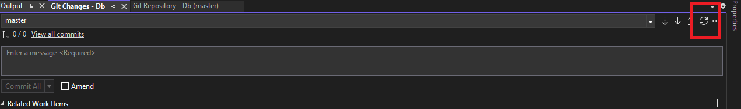

1. Go back to **Git Repository**
2. Expand **remotes/origin**, select the branch, right-click and select delete.

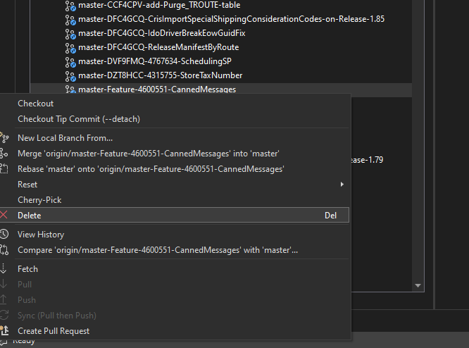

1. Delete all your branches.
2. Just to sync up repository, go back to Git Changes, and do a sync again.

